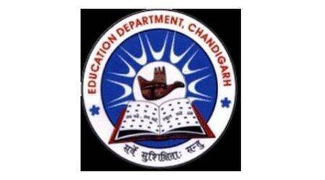
School Code : 24208 | Affiliation No. 2620025
GOVERNMENT MODEL SENIOR SECONDARY SCHOOL
SECTOR 38 WEST DMC CHANDIGARH. PHONE : 0172-2617001
Website: www.gmsss38wdmc.in. E-Mail ID: gsss38west@yahoo.in

MEMO NO : DATE:5/5/2021
BUILDING CERTIFICATE
It is hereby certified that building is constructed with safety measures and rules by UT, Chandigarh Administration.

PRINCIPAL
GMSSS 38 WEST DMC

